Don’t miss the opportunity to order a Miami-Dade Sheriff’s Office 2026 Championship Badge and lapel pin
for $150.
Miami-Dade County will be hosting three separate sports championship series games: the College Football Playoff National Championship game, the World Baseball Classic Championship game, and the FIFA World Cup Bronze Medal game.

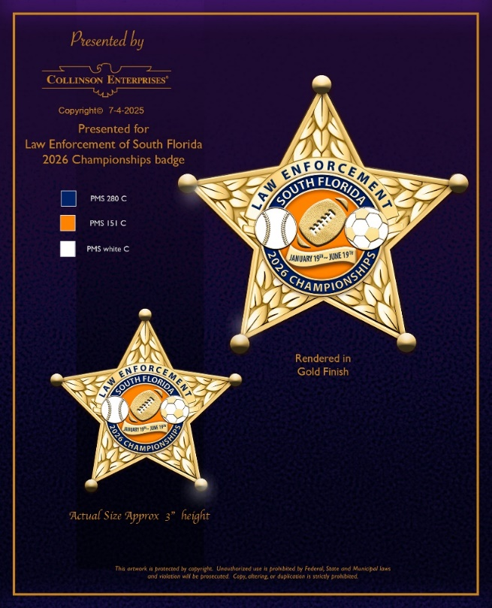

Please fill in the form below and return to POAToffice@msn.com

ZELLE – send payment of $150.00 to poatoffice@msn.com and write in Memo Section: Championship Badge(s).

Please screenshot your confirmation of payment and return with the below information.

Name | Address | Telephone Number | # of Badges

- Badge is made in the USA and has a lifetime warranty from the manufacturer.

